**[yg;gpusak;**

**cyfpd; ve;j gFjpfspy; Vw;gl;lJ**

Kjyhk; cyfj;jpy; kdpjh;fs; G+kpapd; ve;j gFjpapy; tho;e;jhh;fs;? [yg;gpusak; cyfj;jpd; ve;j gFjpapy; Vw;gl;lJ? vd;gJ Fwpj;J ,e;j mjpfhuj;jpNy ehk; ghh;g;Nghk;. [yg;gpusak; vd;gJ Kjyhk; cyfj;J kf;fspd; mf;fpuk epiwtpw;fhf Njtdhy; nfhLf;fg;gl;l epahaj;jPh;g;G MFk;. Kjyhk; cyfj;jpd; filrp fhyj;jpy; [dq;fSila mf;fpukk; epiwtile;jpUe;jJ. Njtd; me;j [dq;fs; kde;jpUe;j Ntz;Lk; vd;W Nehth %ykhf gpurq;fpj;jhh;. ,ijNa 2NgJ:2:5y; “ePjpia gpurq;fpj;jtdhfpa Nehth” vd;W $wg;gl;bUf;fpd;wJ. Mk; Kjyhk; cyfj;jpd; mf;fpukk; epiwtile;jNghJ Njtd; Nehth %ykhf mth;fSf;F kde;jpUe;Jk;gb Nghjpj;jhh;. Mdhy; Kjyhk; cyfj;jhh; xUtUk; Nehthtpd; gpurq;fj;jpw;F fPo;gbatpy;iy vd;W 1NgJ:3:20y; $wg;gl;bUf;fpd;wJ. vdNt Njtd; [yg;gpusaj;jpd; %yk; mth;fis mopf;f KbTnra;jhh;. Mjhk; ghtk; nra;jjpypUe;J fpl;ljl;l 1700 tUlq;fs;jhd; Kjyhk; cyfk; ,Ue;jpUf;fpd;wJ. mjw;Fs; me;j cyfkhdJ jdJ mf;fpuk epiwit mile;jpUf;fpd;wJ. [yg;gpusaj;jpypUe;J ,uz;lhk; cyfk; Muk;gpj;jJ. fpl;ljl;l 4300 Mz;Lfshf ,uz;lhk; cyfk; ,Ue;J tUfpd;wJ. ,uz;lhk; cyfkhdJ 4300 Mz;Lfs; fopj;J ,g;NghJjhd; jdJ mf;fpuk epiwit mile;jpUf;fpd;wJ. ehk; ,e;j cyfj;ijNa Jd;khh;f;fkhd cyfk; vd;W $Wfpd;Nwhk; vd;why; Kjyhk; cyfkhdJ ve;j mstpw;F Jd;khh;f;fkhf ,Ue;jpUf;Fk; vd;W ePq;fs; nfhQ;rk; Nahrpj;J ghUq;fs;.

**vUrNyk; Njrj;jpw;fhd epahaj;jPh;g;G:** mf;fpukk; epiwtile;j ,];uNay; cyfj;ij Njtd; fp.gp.135y; epahae;jPh;j;jhh;. me;j epahaj;jPh;g;ghdJ Nuhk gilfs; %ykhf nfhLf;fg;gl;lJ. Kjyhk; cyfj;ij Njtd; [yg;gpusaj;jhy; epahae;jPh;j;jhh;. ,];uNaypa cyfj;ij epahae;jPh;f;Fk;NghJ Njtd; ,];uNay; [dq;fis kl;Lk; epahae;jPh;f;ftpy;iy. vUrNyk; Njrj;ijAk; epahae;jPh;j;jhh;. vUrNyk; Njrj;jpy; rpe;jg;gl;l Fw;wkw;w ,uj;jj;jpw;fhf ,];uNay; Njrj;ijak; epahae;jPh;j;jhh;. xU epyj;jpy; Fw;wkw;w ,uj;jk; rpe;jpdhy; Njtd; me;j epyj;ijAk; epahae;jPh;g;ghh;. MdhYk; Njtd; mjw;fhd xU vy;iyia itj;jpUg;ghh;. me;j msT tUtjw;F Kd;dh; me;j epyj;ij epahae;jPh;f;fkhl;lhh;. ,];uNay; Njrj;jpw;F Fw;wkw;w ,uj;jj;jpw;fhd vy;iyahdJ ,NaR fhyj;jpy; mth;fs; ,NaR kw;Wk; rigahiu nfhiynra;jjd; %yk; epiwTf;Fte;jJ. vdNt fp.gp.135y; ,];uNaypy; ,uz;L epahaj;jPh;g;Gfs; ele;jd. xd;W ,];uNay; [dq;fSila mf;fpuk epiwTf;fhf mth;fs; mopf;fg;gl;lhh;fs; my;yJ mbikfshf nfhz;Lnry;yg;gl;lhh;fs;. ,J ,];uNay; [dq;fSf;fhd epahaj;jPh;g;G. ,];uNay; Njrj;jpw;fhd epahaj;jPh;g;G vJ? ,];uNay; Njrj;jpd; epykhdJ Kw;wpYk; mopf;fg;gl;L ghOk; tdhe;juKk; Mf;fg;gl;lJ. mJtiu gyd;nfhLf;Fk; G+kpahf> ghYk; NjDk; XLk; Njrkhf ,Ue;j ,];uNay; NjrkhdJ ghiytdkhfp NghdJ. Fbfsw;w NjrkhdJ.

**ehd; mth;fisg; G+kpNahLq;$l mopj;Jg;NghLNtd; Mjp:6:13:** Kjyhk; cyfj;jpw;fhd epahaj;jPh;g;igf; Fwpj;J Njtd; Mjp:6:13y; $Wk;NghJ “ehd; mth;fisg; G+kpNahLq;$l mopj;Jg;NghLNtd;” vd;Wjhd; $Wfpd;whh;. ,];uNay; [dq;fSf;F vg;gb G+kpNahL Nrh;j;J epahaj;jPh;g;G nfhLj;jhNuh mNjNghy Kjyhk; cyfj;jpw;Fk; ,uz;L fhuzq;fSf;fhf epahaj;jPh;g;G nfhLf;fg;gl;lJ vd;W ,e;j trdj;jpy nfhLf;fg;gl;bUf;fpd;wJ. |G+kpNahLq;$l mopj;Jg;NghLNtd;” vd;why; mth;fisAk; mopg;Ngd;> mth;fs; tho;e;j G+kpiaAk; mopg;Ngd; vd;W Kjyhk; cyfj;jpw;F mth; nfhLf;fg;NghFk; ,uz;L epahaj;jPh;g;igf; Fwpj;J $Wfpd;whh;. G+kp vjw;F mopf;fg;glNtz;Lk;? Kjyhk; cyfj;J kdpjh;fs; Njt[dq;fsJ Fw;wkw;w ,uj;jj;ij rpe;jpajhYk;> me;j Fw;wkw;w ,uj;jj;jpw;fhd vy;iyahdJ [yg;gpusa fhyj;jpy; Kw;Wngw;wpUe;j fhuzj;jpdhYk; Njtd; Kjyhk; cyfj;ij mth;fs; tho;e;j g+kpNahLk; Nrh;j;J mopj;jhh;.

**Kjyhk; cyfj;jpy; xU Nytpah; tFg;ghh; njhpe;njLf;fg;gl;lhh;fs;:** Kjyhk; cyfkhdJ Njt[dq;fspd; my;yJ Fw;wkw;w ,uj;jj;jpdhy; epuk;gpapUe;jJ vd;gJ ekf;F Mr;rhpakhf ,Uf;fyhk;. Kjyhk; cyfj;jpy; MNgy;> VNdhf;F Nghd;W xU rpy Njt[dq;fis Fwpj;Jjhd; ekf;F njhpAk;. ,uj;jk; rpe;jpa Njt[dq;fis nghWj;jtiu MNgiy gw;wp kl;Lk; jhd; ekf;F nfhLf;fg;gl;bUf;fpd;wJ. mjdhy; Kjyhk; cyfj;jpy; NtW ve;j Fw;wkw;w ,uj;jKk; rpe;jg;gltpy;iy vd;W ehk; vz;zptplf;$lhJ. Mrhpg;G $lhuj;jpy; %d;W tif Nytpah;fs; ,Uf;fpd;whh;fs;. Nytpah;fs; vd;gth;fs; ,uzlhk; epiy Mtpf;Fhpa tFg;ghuhth;. rigahh; nja;tPf rhPu ,ul;rpg;ig ngWtjhy; mth;fs; Kjyhk; epiy Mtpf;Fhpa tFg;ghh; Mth;. Mrhpg;G $lhuj;jpy; %d;W Nytpah;fs; fhl;lg;gl;bUf;fpd;whh;fs; vd;why; %d;W cyfj;jpypUe;J %d;W tif ,uz;lhk; epiy Mtpf;Fhpa tFg;ghh; njhpe;njLf;fg;gLthh;fs; vd;W mh;j;jk;. mjpy; xU tFg;ghh; Kjyhk; cyfj;jpypUe;Jk; kw;nwhU tFg;ghh; ,uz;lhk; cyfj;J Gw[hjpfsplj;jpypUe;Jk;> %d;whtJ tFg;ghh; ,];uNaypa cyfj;jpypUe;Jk; njhpe;njLf;fg;gLthh;fs;. vdNt Kjyhk; cyfj;jpypUe;J xU ,uz;lhk;epiy Mtpf;Fhpa tFg;ghh; njhpe;njLf;fg;gl;lhh;fs;. Kjyhk; cyfj;jpYk; ,];uNaypNy rpe;jg;gl;lijg;Nghy mjpfkhf Fw;wkw;w ,uj;jk; rpe;jg;gl;bUf;Fk;. ,d;Dk; nrhy;yg;Nghdhy; ,];uNaiytpl mjpf Jd;khh;f;fh;fshf Kjyhk; cyfj;jhh; ,Ue;jjhh;fs;. vdNt ,];uNayh;fistpl mjpfkhfNt Njt[dq;fSila ,uj;jk; Kjyhk; cyfj;jpy; rpe;jg;gl;bUf;fpd;wJ.

**,d;iwa ghiytdq;fs;:** Fw;wkw;w ,uj;jk; rpe;jg;gl;ljw;Fk; Nrh;j;Jjhd; Kjyhk; cyfj;jpd; G+kpahdJ [yg;gpusaj;jpd;NghJ epahae;jPh;f;fg;gl;lJ. Fw;wkw;w ,uj;jj;ij rpe;jpajw;fhf ,];uNaiy ghiytdkhf;fpaJNghy Kjyhk; cyfj;J kf;fs; tho;e;j ,lj;ijnay;yhk; Njtd; gho;gLj;jpg;Nghl;lhh;. mjdhy; mth;fs; tho;e;j epyg;gFjpfs; vy;yhk; ghiytdq;fshapd. Kjyhk; cyfj;jhh; tho;e;j ,lk; ghiytdq;fshapd vd;w xU jfty; ,g;NghJ ekf;F fpilj;jpUf;fpd;wJ. ,e;j jtiy itj;J ehk; Kjyhk; cyfj;jpy; kf;fs; ve;nje;j ,lj;jpy; tho;e;jhh;fs; vd;W fz;Lgpbj;Jtpl KbAkh? fz;bg;ghf KbAk;. ,d;W cyfj;jpy; vq;nfy;yhk; ghiytdk; ,Uf;fpd;wNjh me;j ,lnky;yhk; Kjyhk; cyfj;J kdpjh;fs; tho;e;j ,lk; vd;W ePq;fs; cWjpnra;J nfhs;syhk;. ,jpNy ehk; ftdj;jpy; nfhs;sNtz;ba Kf;fpakhd tp\ak; njhiyJ}ukhf ,Uf;Fk;> fly;fle;J ,Uf;Fk; ghiytdq;fis ehk; fzf;fnyLf;ff; $lhJ. nkhj;jkhf njhlh;rpahf ,Uf;Fk; ghiytdq;fisNa ehk; fzf;fpnyLf;f Ntz;Lk;. Vnddpy; mg;NghJ kDf;Fyk; G+kpapd; xU Fwpg;gpl;l gFjpapy; njhlr;rpahfNt tho;e;jhh;fs;.

**,d;iwa ghiytdq;fNs md;iwa kf;fs; tho;e;j ,lkhFk;:** ,e;j fhhpaq;fisnay;yhk; ehk; fzf;fpnyLj;J ghh;j;NjhNkahdhy; Kjyhk; cyfj;jpy; kdpjh;fs; ,d;iwa rfhuh ghiytdg; gFjp> kj;jpa fpof;F ghiytdg; gFjp> rpe;J rkntsp ghiytdg;gFjp> f[fp];jhd;> j[pfp];jhd;> u\;ah> irdh> kq;Nfhypah Mfpa gFjpfspy; ,Uf;Fk; ghiytdq;fs; Mfpa gFjpfspy;jhd; tho;e;jpUg;ghh;fs; vd;w KbTf;F ehk; tuyhk;. ,e;j ghiytdq;fs; vy;yhNk njhlh;r;rpahf ,Uf;fpd;wJ. mJNt Fw;wkw;w ,uj;jk; rpe;jg;gl;ljw;fhf [yg;gpusaj;jpd; %ykhf ghiytdkhf;fg;gl;l Kjyhk; cyfj;jpd; gFjpfshFk;. ,q;Fjhd; Kjyhk; cyfj;J kdpjh;fSk; tho;e;jpUf;fpd;whh;fs;.

**[yg;gpusak; vg;gb tdhe;juj;ij cz;lhf;Fk;?** ,d;W ghiytdkhf fhzg;gLk; gFjpjhd; Kjyhk; cyfj;jpy; kdpjh;fs; tho;e;j gFjp. ,e;j gFjpiajhd; Njtd; [yg;gpusaj;jhy; mopj;jhh;. mjdhy;jhd; mit ghiytdq;fshapd. ,g;Ngh rpyUf;F xU re;Njfk; tuyhk;. ePhpdhy; xU ,lk; epug;gg;gl;lhy; mjhtJ [yg;gpusak; te;jhy; mJ nropg;ghd epykhfj;jhNd khwKbAk;. my;yJ mJ xU rJg;G epykhfj;jhNd khWk;. Mdhy; vt;thW [yg;gpusak; te;j ,lq;fshdJ ghiyepyq;fshf khwpd vd;gNj me;j Nfs;tp. ,d;Wk; $l vj;jidNah ,lq;fspy; nts;sk; tUfpd;wJ. 10 my;yJ 20 ehl;fs; nts;sk; Njq;fp fplf;fpd;wJ. MdhYk; mJ ghiytdkhf khWtjpy;iy. gpd;dh; vg;gb Nehth fhyj;J [yg;gpusak; kl;Lk; G+kpia ghiytdkhf;fpaJ? ,J xU rhpahd Nfs;tpjhd;. Mdhy; Njtd; G+kpia nropg;gila nra;tjw;fhf [yg;gpusaj;ij cz;Lgz;ztpy;iy. G+kpia mopf;fNt mjhtJ Njt[dq;fSila ,uj;jk; rpe;jg;gl;l gFjpfis mopf;fNt me;j ,lj;ij ghiytdkhf;fNt [yg;gpusaj;ij Vw;gLj;jpdhh;. vdNt Moj;jpd; Cw;Wf; fz;fs; gpse;J ntspte;j [yg;gpusa jz;zPhpy; G+kpia ghiytdkhf;Fk; mstpw;F mjd; Ph msT mjpfkhfNth FiwthfNth ,Ue;jpUf;fyhk;. jz;zPhpy; Ph msT Fiwe;jhNyh mjpfkhdhNyh $l epykhdJ ghiytdkhf tha;g;G ,Uf;fpd;wJ. my;yJ kz;iz kylhf;Fk; Ntjpg;nghUs; VjhtJ me;j jz;zPhpy; ,Ue;jpUf;fyhk;. vJ vg;gbNah Njtd; [yg;gpusaj;jpd; %yKk; G+kpia ghiytdkhf;f ty;yikAilatuhf ,Uf;fpd;whh;. mjw;F Kjyhk; cyfk; xU cjhuzkhf ,Uf;fpd;wJ. kio nghopahky; ,Uf;f nra;Jk; xU epyj;ij ghiytdkhf;f ty;yik cilatuhf ,Uf;fpd;whh;. mjw;F ,];uNay; xU cjhuzkhf ,Uf;fpd;wJ.

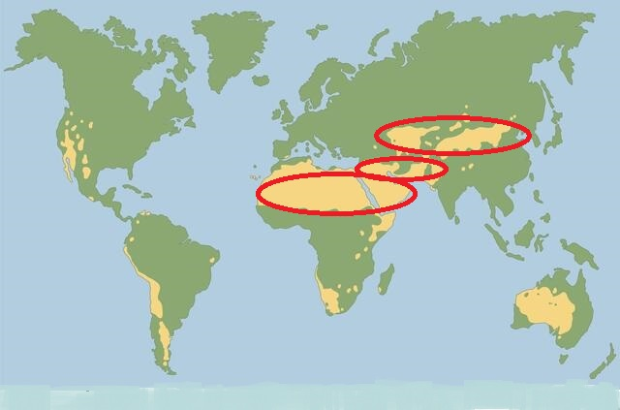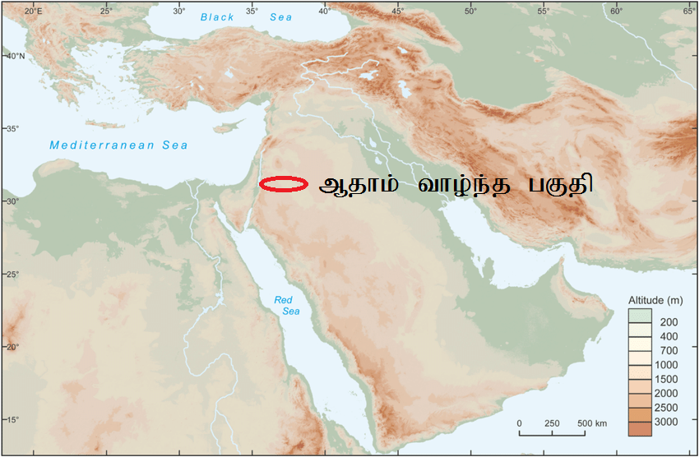

**Kjyhk; cyfj;J kdpjh;fspd; %d;W gphpTfs;:** ,e;j ghiytdq;fs; INuhg;ghtpy; fhzg;gltpy;iy. mitahTk; MrpahtpYk;> Mg;gphpf;fhtpYk; kl;LNk fhzg;gLfpd;wd. ,e;j ghiytdq;fis %d;W gphpTfshf gphpf;fyhk;. rTjpmNugpah kw;Wk; rfhuh ghiytdk; xNu Neh;Nfhl;by; ,Ug;gjhy; ,J xU gphpthf ghpf;fyhk;. mNugpa jPgfw;gk; jtph;j;j kj;jpa fpof;F gFjp kw;Wk; rpe;J rkntspg; gFjpia xU gphpthf gphpf;fyhk;. kw;Wk; f[fp];jhd;> j[fp];jhd;> u\;ah> kq;Nfhypah> rPdh Mfpa gFjpfspy; cs;s ghiytdq;fis xU gFjpahf gphpf;fyhk;. Vd; ,g;gb %d;W gphpthf gphpf;f Ntz;Lk;? ,uz;lhk; cyfj;jpNy Njtd; vg;gb Nehthtpd; %d;W gps;isfspypUe;J (fhk;> Nrk;> ahg;Ngj;J) %d;W [df;$l;lj;ij cz;Lgz;zp mth;fs; xt;nthUtUf;Fk; jdpj;jdp ,lj;ij nfhLj;jhNuh mNjNghy Kjyhk; cyfj;jpYk; Njtd; Mjhkpd; re;jjpaiu %d;W gphpTfshf gphpj;J ,d;W ,Uf;Fk; ,e;j %d;W ghiytdg; gFjpfspy; FbNaw;wpdhh;.

**%d;W ghpTfs; vJ?** Kjyhk; cyfj;jpd; me;j %d;W gphptpdh; ahh;? Kjypy; fhaPdpd; re;jjp> mLj;J Mjhkpd; kw;w re;jjp vd;w ,uz;L re;jjpah; Kjy; ,uz;L gphptpy; tUfpd;whh;fs;. %d;whk; gphpT ve;j re;jjp? ,uz;lhk; cyfj;jpy; tk;rtuyhw;wpy; cs;s ,dkhdJ jdpj;j xU FOthf gphpf;fg;gl;bUe;jhh;fs;. tk;rtuyhW vd;why; vd;d? Nkrpah ve;j tk;rj;jpy; tUthNuh me;j tk;rj;jpd; tuyhNw tk;r tuyhuhFk;. ,uz;lhk; cyfj;jpy; Mgpufhkpd; tk;rNk Nkrpahtpd; tk;rkhFk;. vdNt mth;fs; jdpahf gphpf;fg;gl;lhh;fs;. mNjNghy Kjyhk; cyfj;jpy; Nrj;Jjhd; Nkrpahtpd; tk;rj;jpd; Muk;gkhthd; (MgpufhKk; me;j tk;r topapy; te;jtd;jhd;). vdNt Nrj;jpd; re;jjpapdh; Mjhkpd; kw;w re;jjpapdh; ,Ue;j gFjpfspypUe;j jdpj;J gphpf;fg;gl;L xU jdpj;j ,dkhf ,Ue;jpUg;ghh;fs;. ehd; ,ij vNjh NghwNghf;fpy; nrhy;yptpl;L Nghftpy;iy. ,e;j %d;W gphptpdh; jdpj;jdpahf ,Ue;jhh;fs; vd;gij ehk; ,g;NghJ Ntj Mjhuj;jpd; %ykhf ep&gpf;fg; Nghfpd;Nwhk;.

**MjhKk; kw;w mtdJ re;jjpaUk; vq;F thrkhapUe;jhh;fs; (Mjhk; Ch;: NahR:3:16):**

Kjypy; vNjidtpl;L Juj;jg;gl;l Mjhk; vq;F FbapUe;jhd; vd;W ehk; ghh;g;Nghk;. ,jw;F Ntjj;jpy; VjhtJ Mjhuk; ,Uf;fpd;wjh? NahR:3:16y; Mjhk; Ch; vd;W xU efuj;ijf; Fwpj;J $wg;gl;bUf;fpd;wJ. me;j ,lkhdJ Nahh;jhDf;F fpof;Nf mh;Ndhd; Mw;wpw;F njw;Nf ,Ue;jpUf;fpd;wJ. Mjhk; ,e;j Chpd; Rw;wp cs;s gFjpfspNyNa Rw;wp jphpe;jpUf;fyhk;. Mjhkpdpj;jk; g+kp rgpf;fg;gl;bUe;jJ. vdNt mtd; tho;e;j ,e;j ,lKk; rgpf;fg;gl;LjhdpUe;jJ. rgpf;fg;gl;lJ vd;why; vd;d mh;j;jk;? G+kp mtDf;F jd; gyid nfhLf;fhJ. vdNt mtdhy; tptrhak; nra;aKbahJ. MfNt mtd; xNu ,lj;jpy; jq;fp thoKbahJ. cztpw;fhf miye;J jphpfpd;wtdhfNt mtd; ,Ue;jpUg;ghd;. Mjhk; Ch; vd;w efuj;jpd; mUfpy; cs;s gFjpfspy; mtd; jdJ gps;isfNshL miye;J jphpfpd;wtdhf ,Ue;jpUg;ghd;. Mjhkhdtd; jdJ tho;ehs; OKtJk; Mjhk; Chpy; tho;e;jpUf;f tha;g;gpy;iy. Vnddpy; mtd; xU Chpy; thohky; ehNlhb tho;f;if tho;e;jhd; vd;W ghh;j;Njhk;. vdNt me;j Chpy; Mjhk; jdJ filrp fhyj;jpy; tho;e;J mlf;fk; nra;ag;gl;bUf;fyhk; vd;W ek;g ,lkpUf;fpd;wJ. mtid mlf;fk; nra;j CUf;F Mgpufhk; kw;Wk; Nyhj;J mq;F tho;e;j fhyj;jpy; my;yJ mjw;F Kd;ghfNt NjtdJ czh;j;Jjypdhy; me;j ngaiu itj;jpUg;ghh;fs;. NkhNr ,q;F tUk;NghJ mJ Mjhk; Ch; vd;Nw me;j Ch; miof;fg;gl;lJ. vdNt Ntjj;jpYk; mt;thNw gjpT nra;ag;gl;bUf;fpd;wJ. Mjhk; jdJ gps;isfSld; ,e;j gFjpapNyNa tho;e;jpUf;fpd;whd;. ,e;j ,lj;jpypUe;Nj Kjyhk; cyfj;jpd; kDf;FykhdJ gutpaJ.

Mjhkpd; kw;w re;jjpah; vq;F FbapUe;jhh;fs; vd;gJ mLj;j Nfs;tp. Mjhk; Nrj;ij ngw;w gpd;dUk; mNef Fkhuh;fisAk;> Fkhuj;jpfisAk; ngw;nwLj;jhd; vd;W Ntjk; $Wfpd;wJ. Mjhk; Ch; kw;Wk; mjd; njw;fhf mNugpa jPgfw;g gFjpfis Mjhkpd; kw;w gps;isfs; Mf;fpukpj;jhh;fs;. me;j gFjpfspy;jhd; igNrhd; MWk;> fPNfhd; MWk; Xbf;nfhz;bUe;jJ. Mjhkpd; re;jjpah; mq;F gy;fpngWf Muk;gpj;jTld; mNugpa jPgfw;gj;jpypUe;J rfhu gFjpia Nehf;fp efh;e;J rfhuhtpd; Nkw;F gFjpahd ml;yhz;;bf; fly;fiu tiu te;jhh;fs;. Nrj;jpd; re;jjpah; Nrj;Jtpd; %ykhf kl;Lk; te;j re;jjpauhth;. mNjNghy fhaPdpd; re;jjpapdUk; fhaPd; vd;w xU jdp kdpjd; %ykhf te;j te;jjpapduhth;. Mdhy; Mjhkpw;F Nrj;ij jtpuTk; epiwa kfd;fSk; kfs;fSk; ,Ue;jhh;fs;. vdNt Mjhkpd; kPjpahd re;jjpah; (fhaPd;> Nrj;jpd; re;jjpapdh; jtph;J kPjKs;s nkhj;j Mjhkpd; re;jjpapdh;) Nrj;jpd; re;jjpaiutpl> fhaPdpd; re;jjpaiutpl kpf mjpf vz;zpf;ifapy; ,Ue;jpUg;ghh;fs;. mjdhy; Mjhkpd; kw;w re;jjpah; mNugpa jPgfw;gj;ijAk; rfhuh ghiytdj;ijAk; Mf;fpukpj;jhh;fs;. fhaPd; kw;Wk; Nrj;jpd; re;jjpaiutpl Mjhkpd; kw;w re;jjpahpd; vz;zpf;if gy klq;F mjpfkhf ,Ue;jjhy; mth;fSf;F tho kpfg;nghpa ,lk; Njitg;gl;lJ. ,d;W ghiytdq;fshf ,Uf;Fk; rfhuh ghiytdk; [yg;gpusaj;jpw;F Kd;dh; ghiytdkhf ,Ue;jjpy;iy. mjpy; mWfs; Xbd. mij tpQ;QhdKk; cWjpnra;fpd;wJ. ,q;Fk; Kjyhk; cyfj;J kf;fs; tho;e;jpUf;fpd;whh;fs;. ,J kpfg;nghpa ghiytdkhf ,Ug;gjhy; ,q;Fjhd; mjpfkhd Kjyhk; cyfj;J kdpjh;fs; tho;e;jpUg;ghh;fs; vd;W vz;z ,lkpUf;fpd;wJ. ehk; rfhuhtpd; gFjpfspy; Njhz;b ghh;j;jhy; fz;bg;ghf [yg;gpusaj;jpw;F Ke;ja ehfhPfj;ij ehk; rfhuhtpd; gy ,lq;fspNy ghh;f;f KbAk;. $ba tpiutpy; rfhuh ehfhPfk; vd;W cyfj;jpw;F Qhdpfs; ,ij ntspg;gLj;Jthh;fs;.

**fhaPdpd; re;jjpah; vq;Nf thrkhapUe;jhh;fs;?**

fhapDk;> MNgYk; ,];uNaypNy FbNawpapUe;jhh;fs;. fhaPd; mNgiy nfhiynra;jjhy; fhapd; ,];uNay; Njrj;jpypUe;J Juj;jptplg;gLfpd;whd;. ,];uNaypypUe;J Juj;jg;gl;l fhaPd; vNjDf;F fpof;fhd Nehj; vd;w Njrj;jpy; FbNawpdhd; vd;W Mjp:4:16y; $wg;gl;bUf;fpd;wJ. VNjd; vd;gJ vh;Nkhd; kiyAk; mjd; fpof;Nf ,Ue;j yPgNdhd; gs;sjhf;Fk; vd;W ehk; Vw;fdNt ghh;j;jpUf;fpd;Nwhk;. fhaPd; FbNawpa Nehj; NjrkhdJ ,d;iwa lkh];f]; mUfpy; ,Ue;jpUf;fyhk;. mq;F mtd; te;j gpwNf mtDf;F jpUkzk; ele;jpUf;fpd;wJ. mtd; jdJ cld;gpwe;j jq;ifiaNa kze;jpUf;fpd;whd;. Kjyhk; cyfj;jpy; cld;gpwg;GfSf;F ,ilNa jpUkzk; vd;gJ ghtk; my;y. ,jpypUe;J fhapDk;> MjhKk; mtd; re;jjpaUk; njhlh;gpyjhd; ,Ue;jpUf;fpd;whh;fs; vd;W njhpfpd;wJ. mth;fs; ,UtuJ ,Ug;gplKk; mUfUNfjhd; ,Ue;jpUf;fpd;wJ vd;gJk; cWjpahfpd;wJ. Mjhk; ChpypUe;J jk];FthdJ fpl;ljl;l 275 fp.kP. Juj;jpNyNa ,Ue;jJ. MjhkplkpUe;J fhaPd; ngz; vLj;j gpd; fhaPd; xU jdpj;j ,d FOthf cUthf Muk;gpj;jhd;. mtd; VNdhf;if ngw;wgpd;dh; xU efuj;ij fl;bdhd; vd;W Ntjj;jpy; $wg;gl;bUf;fpd;wJ. fhaPd; VNjDf;F fpof;Nf mjhtJ ,d;iwa rphpah gFjpapy; FbapUe;jhd; vd;gJ Ntjj;jpy; gjpT nra;ag;gl;l rj;jpakhFk;. ehk; Vw;fdNt cyfj;jpd; ghiytdg; gFjpfis %d;W gphpthf gphpj;jpUe;Njhk;. mjpy; ,e;j rphpahtpd; gFjp vjpy; tUfpd;wJ?; kj;jpapy; cs;s ghiytdg; gFjpfspy; tUfpd;wJ. kj;jpa fpof;fpypUe;J rpe;J rkntsp tiu gutpapUf;Fk; me;j kj;jpa ghiytdg; gFjpfspNyjhd; fhaPdpd; re;jjpah; FbapUe;jpUg;ghh;fs;. VNjDf;F fpof;fhf rphpahtpd; gFjpapy; FbNawpa fhaPdpd; re;jjpapdh; ,jf;Nfy; MW kw;Wk; rpe;J MW Nehf;fp gutp fpof;Fg; gFjp Nehf;fp tpUj;jpaile;jhh;fs;.

**rpe;J rkntsp ehfhPfk;:** rpe;J rkntspapy; fhaPdpd; re;jjpah; FbNawpaJ Fwpj;J nfhQ;rk; tphpthfNt ghh;g;Nghk;. rpe;J rkntsp vd;gJ ,d;iwa ,e;jpahtpd; F[uhj;> ,uh[];jhd;> gQ;rhg;> `hpahdh> f\;kPh;> kw;Wk; ghf;fp];jhdpd; rpe;J Mw;wpd; neLf cs;s gFjpfis cs;slf;fpajhFk;. rpe;J rkntspapy; ,d;W ehk; ghh;j;NjhNkahdhy; rpe;J rkntspapd; njd; gFjpahdJ ghiytdkhf ,Uf;fpd;wJ. ghfp];jhdpy; njd;gFjpapy; Cholistan desert ,Uf;fpd;wJ. mij njhlh;e;J ,e;jpahtpy; Thar desert ,Uf;fpd;wJ. rpe;J rkntspapd; ,e;j ghiytdg; gFjpapYk; fhaPdpd; re;jjpah; FbNawpapUf;f Ntz;Lk;. me;j gFjpfspy; rpe;jg;gl;l Fw;wkw;w ,uj;jj;jpw;fhf rpe;J rkntspapd; me;j gFjpfs; ghiytdkhf;fg;gl;bUf;f Ntz;Lk;. rpe;J rkntsp ehfhPfj;ij ehk; ,uz;L gFjpfshf gphpf;fNtz;Lk;. [yg;gpusaj;jpw;F Ke;ja rpe;J rkntsp ehfhPfk;. mJ fhaPdpd; re;jjpapduhy; Vw;gLj;jg;gl;lJ. [yg;gpusaj;jpw;F gpe;ja rpe;J rkntsp ehfhPfk;. mJ $\pd; re;jjpauhy; Vw;gLj;jg;gl;lJ (,ij Fwpj;J gpwF ehk; tphpthf ghh;g;Nghk;). ,g;NghJ Kjypy; rpe;J rkntspapd; ghiytdq;fshf ,Uf;Fk; njd; gFjpapy; [yg;gpusaj;jpw;F Ke;ja ehfhPfk; ,Ue;jJ mjhtJ ehfhPfj;jpy; Nkk;gl;l kdpjh;fs; tho;e;jhh;fs; vd;gjw;F ehk; rpy Mjhuq;fis ghh;g;Nghk;. mjd; gpd;dh; me;j ehfhPfkhdJ fhaPdpd; ehfhPfk; vd;gij epUgpg;Nghk;.

**rpe;J vOj;Jf;fs; thrpf;f Kbatpy;iy:** rpe;J rkntspapd; ehfhPfj;jpw;F Ke;ja ehfhPfk; vd;W nrhy;yg;glf;$ba nkrgNlhkpahtpy; fz;Lgpbf;fg;gl;l vOj;Jf;fisf;$l ek;khy; thrpf;f Kbfpd;wJ. Mdhy; rpe;J rkntsp vOj;Jf;fis ,d;Wk; thrpf;fKbatpy;iy. Vnddpy; me;j vOj;Jf;fs; [yg;gpusa fhyj;jpw;F Ke;ja vOj;Jf;fs;. me;j vOj;Jf;fs; ,g;NghJ tof;nfhope;Jtpl;lJ. vdNt mij ek;khy; Ghpe;Jnfhs;s Kbatpy;iy. rpe;J rkntspapd; vy;yh vOj;Jf;fSk; thrpf;f Kbahjjhf ,y;iy. rpe;J rkntspapd; fpWf;fy; vOj;Jf;fs; jkpo;ehl;by; fz;Lgpbf;fg;gl;l jkpop vOj;Jf;fSf;F Ke;ja vOj;Jf;fNshL xj;Jg;Nghfpd;wJ. vdNt fpWf;fy; vOj;Jf;fs; $\pd; re;jjpauhy; Vw;gLj;jg;gl;l [yg;gpusaj;jpw;F gpe;ja vOj;Jf;fs; vd;gJ cWjpahfpd;wJ. rpe;J rkntspapd; vOj;Jf;fspy; ,g;NghJ ek;khy; thrpf;f Kbahj vOj;Jf;fSk; ,Ug;gjhy; rpe;J rkntspapy; [yg;gpusaj;jpw;F Ke;ja ehfhPfKk; ,Ue;jpUf;fpwJ vd;W ek;g ,lkpUf;fpd;wJ.

**kdpj Njhw;wk;:** rpe;J rkntspapy; xU kdpjDila cUtrpiy fpilf;fg;gl;bUf;fpd;wJ. mtdJ KfrhayhdJ ,g;NghJ ,Uf;Fk; ve;j kdpj ,dj;jpd; rhaNyhLk; xj;Jg;Nghftpy;iy. me;j kdpjDila fz;fshdJ kpfTk; ePskhdjhf ,Uf;fpd;wJ. me;j kdpjdhdtd; [yg;gpusaj;jpw;F Kd;dh; rpe;J rkntspapy; tho;e;j kdpjdhf ,Uf;fyhk;. ,JTk; [yg;gpusaj;jpw;F Kd;dUk; rpe;J rkntsp ehfhPfk; ,Ue;jJ vd;gij ekf;F cWjpgLj;Jfpd;wJ.

**ngz; cUt rpiy:** rpe;J rkntspapy; xU eldkhLk; ngz;zpd; cUtKk; fpilf;fg;ngw;wpUf;fpd;wJ. me;j cUtj;jpYk; fz;fshdJ ePskhdjhfNt fhzg;gLfpd;wJ. me;j rhaypy; ,g;NghJ ve;j kdpj ,dKk; ,y;iy. vdNt mJ fz;bg;ghf [yg;gpusaj;jpw;F Ke;ja kdpjh;fSila cUtkhfNt ,Uf;fNtz;Lk;. vdNt rpe;J rkntsp ehfhPfj;jpd; xU gFjpahdJ [yg;gpusaj;jpw;F Ke;jaJ jhd; vd;W ehk; cWjpahf ek;gyhk;.

**rpe;J rkntspapd; ahid:** rpe;J rkntsp Kj;jpiufspy; ahidapd; cUtk; nghwpf;fg;gl;l Kj;jpiu fpilf;fg;ngWfpd;wJ. ,d;W$l ghfp];jhd; gFjpfspy; ahidfs; fpilahJ. ,e;jpahtpd; cl;gFjpfspy;jhd; ahidfs; cz;L. mg;gbnad;why; vg;gb mth;fs; ahidapd; Kj;jpiuia cUthf;fpapUg;ghh;fs;. [yg;gpusaj;jpw;F Kd;dh; me;j gFjpahdJ ahidfs; epiwe;j gFjpfshfNt ,Ue;jJ. mijf;nfhz;Ljhd; mth;fs; ahid Kj;jpiuia nra;jpUf;fpd;whh;fs;. [yg;gpusaj;jpd;NghJ rpe;J rkntspapy; ,Ue;j ahidfnsy;yhk; mopf;fg;gl;bUf;fpd;wJ. vdNt rpe;J rkntspapy; fz;Lgpbf;fg;gl;l ahid Kj;jpiuahdJ [yg;gpusaj;jpw;F Kw;gl;lJ. [yg;gpusaj;jpw;F gpd;dh; ,e;j gFjpfspy; tho;e;j kdpjh;fs; ahidia ghh;j;jpUf;f Kbahjjhifahy; [yg;gpusaj;jpw;F gpd;dh; ,e;j gFjpapy; tho;e;j kdpjh;fs; ahidapd; cUtj;ij nrJf;fpapUf;f tha;g;gpy;iy. ,e;j ahid Kj;jpiuAk; [yg;gpusaj;jpw;F Kd;dUk; rpe;J rkntspg; gFjpapy; ehfhPfk; ,Ue;jpUf;fpd;wJ vd;gij ekf;F cWjpgLj;Jfpd;wJ.

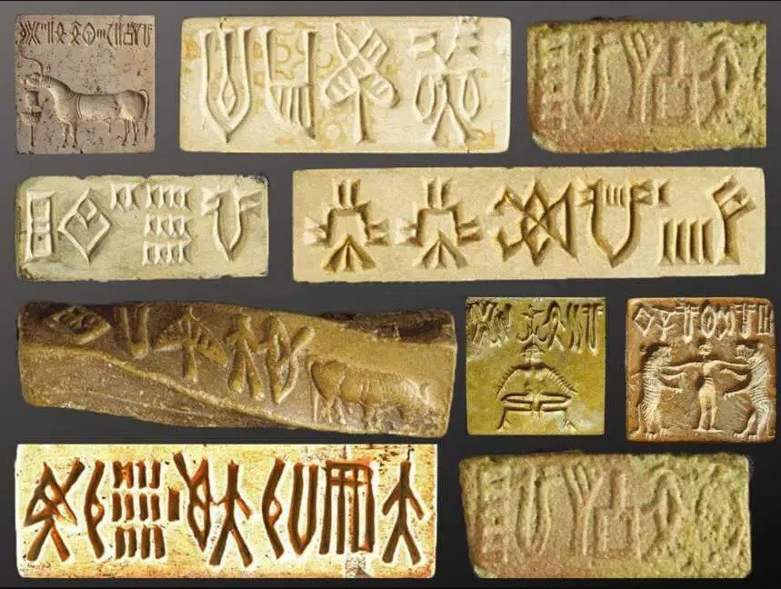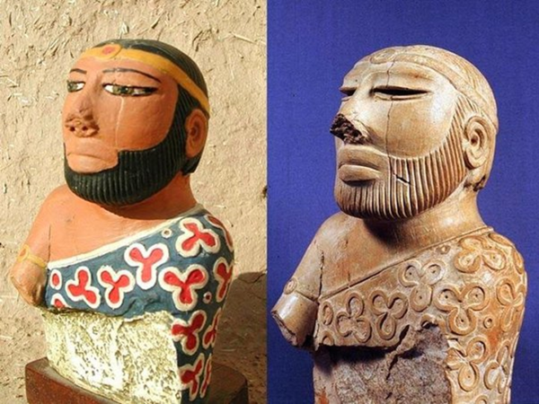

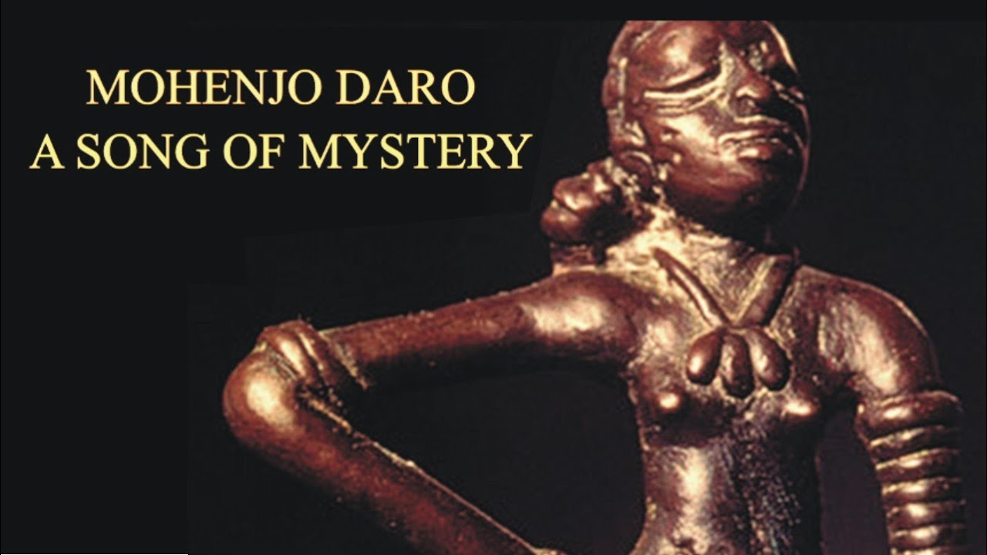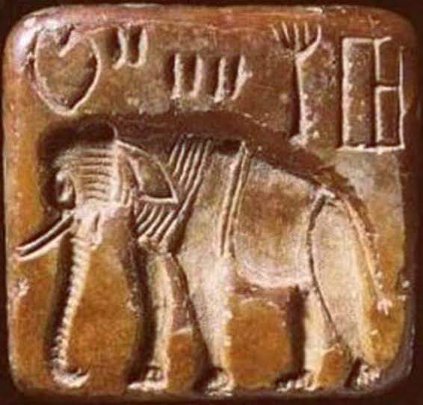

**xw;iw nfhk;G kpUfk;:** rpe;J rkntsp gFjpfspy; fz;Lgpbf;fg;gl;l Kj;jpiufspy; Kf;fpakhdJ xw;iwnfhk;G kpUfkhFk; (unicorns). rpyh; ,ij xU fw;gid kpUfk; vd;W $Wfpd;whh;fs;. rpe;J rkntspapy; fz;Lgpbf;fg;gl;l kw;w vy;yh kpUfq;fspd; Kj;jpiuAk; cz;ikahf ,Uf;Fk;NghJ ,J kl;Lk; fw;gid kpUfkhf ,Uf;Fk; vd;W $WtJ Vw;Wf;nfhs;s ,ayhJ. mq;F tho;e;jth;fs; jhq;fs; ghh;j;j kpUfq;fisNa Kj;jpiuahf tbj;jpUf;fpd;whh;fs;. [yg;gpusaj;jpw;F Kd;dh; ,JNghd;w kpUfq;fs; rpe;J rkntspg;gFjpfspy; tho;e;jpUf;fpd;wJ. [yg;gpusaj;jpy; ,e;j gFjpapy; kl;Lk; tho;e;j ,e;j kpUfkhdJ mopf;fg;gl;bUf;fpd;wJ. ,JTk; rpe;J rkntsp ehfhPfj;jpd; xU gFjp [yg;gpusaj;jpw;F Ke;jaJ vd;gjw;fhd Mjhukhf ,Uf;fpd;wJ.

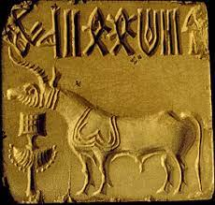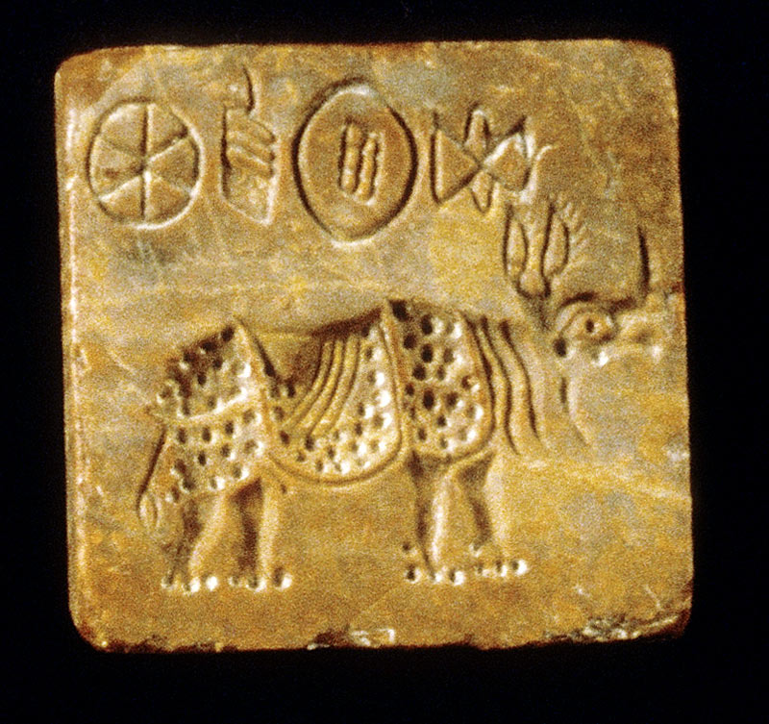

**fhz;lh kpUfk;> Gyp:** rpe;J rkntsp ehfhPf Kj;jpiufspy; fhz;lh kpUfk; Kj;jpiufs;; fhzg;gLfpd;wd. Gyp Kj;jpiufSk; fhzg;gLfpd;wd. Mdhy; me;j kpUfq;fs; vJTk; ,g;NghJ me;j gFjpfspy; ,y;iy. ,jpypUe;J [yg;gpusaj;jpy; fhz;lhkpUfk;> Gyp Mfpa kpUfq;fs; mopf;fg;gl;bUf;fpd;wd vd;gJk;> [yg;gpusaj;jpw;F Kd;dh; ,q;F kf;fs; tho;e;jpUf;fpd;whhfs; vd;gJk;> mth;fs; jhq;fs; fz;zhy; fz;l ,e;j fhz;lhkpUfk;> Gyp Nghd;w kpUfq;fis Kj;jpiuahf tbj;jpUf;fpd;whh;fs; vd;gJk; cWjpahfpd;wJ.

**tk;r tuyhW:** ,Jtiu [yg;gpusaj;jpw;F Kd;dNu rpe;J rkntspapd; xU gFjpapy; xU kdpj ehfhPfk; ,Ue;jJ vd;W ghh;j;Njhk;. ,dpNky; [yg;gpusaj;jpw;F Kd;dh; mq;F ,Ue;j ehfhPfkhdJ fhaPDila re;jjpahpd; ehfhPfNk vd;gij cWjpnra;Ak;gbahd jfty;fis ghh;g;Nghk;. Ntjj;jpy; Nkrpahtpd; tk;r tuyhWNghf fhaPDila tk;r tuyhW kl;LNk nfhLf;fg;gl;bUf;fpd;wJ. vdNt fhaPdJ re;jjpAk; MrPh;tjpf;fg;gl;l re;jpahfNt ,Ue;jpUf;f tha;g;G ,Uf;fpd;wJ. MrPh;tjpf;fg;gl;l me;j fhaPdpd; re;jjpaUf;F Kjyhk; cyfj;jpy; VNjh xU Kf;fpaj;Jtk; ,Ue;jpUf;f Ntz;Lk;.

**VNdhf;F:** jdJ jk;gpia nfhiynra;j fhaPdpd; re;jjp Njtdhy; MrPh;tjpf;fg;gl;lJ cq;fSf;f ek;g nfhQ;rk; f\;lkhfj;jhdpUf;Fk;. fhaPdpd; tk;rkhdJ fhaPdpdpkpj;jk; MrPh;tjpf;fg;gltpy;iy. mtdJ kfdpdpkpj;jk; MrPh;tjpf;fg;gl;lJ. fhaPdpd; kfd; ngah; VNdhf;F. VNdhf;F vd;why; njhlq;fg;gl;lJ vd;W mh;j;jkhFk;. ,td; fhyj;jpy; ,tdhy;jhd; Njtid njhOJnfhs;Sjy; njhlq;fg;gl;lJ. vdNtjhd; Njtd; mtDf;F VNdhf;F vd;w ngaiu itj;jhh;. Jd;khh;f;f re;jjpah; kj;jpapy; Kjy; Kjypy; Njtid njhOJnfhz;ljhy; ,td; Njtdhy; fz;bg;ghf MrPh;tjpf;fg;gl;ltdhfNt ,Ue;jpUg;ghd;. vdNt fhaPdpd; tk;rj;jpy; te;j VNdhf;F re;jjpapy;jhd; Kjyhk; cyfj;jpd; kpfr; rpwe;j ehfhPfkhd rpe;J rkntsp ehfhPfkhdJ Vw;gl;bUf;f tha;g;G ,Uf;fpd;wJ.

**yhNkf;fpd; re;jjpah;:** VNdhf;fpd; tk;rj;jpy; te;j yhNkf;F jhd; Kjyhk; cyfj;jpd; ehfhPfj;jpd; jfg;gd; vd;W Ntjk; $Wfpd;wJ. ,td; MjhkpypUe;J Vohk; jiyKiw Mthd;. ,td; Njtdhy; MrPh;tjpf;fg;gl;l VNdhf;fpd; re;jjpapy; te;jtd;. vdNt rpe;J rkntspapy; yhNkf;Ftpd; re;jjpah; FbNawpapUf;fyhk; vd;W ek;g ,lkpUf;fpd;wJ. Kjyhk; cyfj;jpy; VNdhf;fpd; topte;j yhNkf;fpd; re;jjpapNu Kjy;Kjypy; $lhuq;fspy; tho Muk;gpj;jhh;fs;. mtdJ re;jjpapdNu Kjy; Kjypy; ke;ij Nka;f;f Muk;gpj;jhh;fs;. mtdJ re;jjpapdNu Kjy; Kjypy; ,irf; fUtpfs; thrpf;f Muk;gpj;jhh;fs;. gpj;jis ,Uk;ig Kjyhk; cyfj;jpy; gad;gLj;jpaJ VNdhf;fpd; jiyKiwapdNu. ,itnay;yhk; Mjp:4@19-22 trdj;jpy;; $wg;gl;bUf;fpd;wJ. yhNkf;fpd; re;jjpah; ehfhPfj;jpy; rpwe;J tpsq;fpapUf;fpd;whh;fs; vd;W NtjNk gjpTnra;jpUf;fpd;wJ. vdNt [yg;gpusaj;jpw;F Ke;ja ,e;j rpe;J rkntsp ehfhPfkhdJ fz;bg;ghf fhaPdJ re;jjpahpd; ehfhPfkhfNt ,Ue;jpUf;f Ntz;Lk;. Fwpg;ghf VNdhf;fpd; topte;j yhNkf;fpd; re;jjpaUila ehfhPfkhfNt ,Uf;fNtz;Lk;.

**fpd;duk; - Mjp:4:21:** VNdhf;fpd; topte;j yhNkf;fpd; re;jjpaNu fpd;duj;ij fz;Lgpbj;jhh;fs; vd;W Ntjk; $Wfpd;wJ. rpe;J rkntspapy; fpd;duk; Nghd;w ,irf; fUtp fz;Lgpbf;fg;gl;bUf;fpd;wJ.

**Gs;shq;Foy;:** fhaPdpd; re;jjpaNu Gy;yhq;Foiy fz;L gpbj;jhh;fs; vd;W Ntjj;jpy; $wg;gl;bUf;fpd;wJ; ,e;j Gy;yhq;FoyhdJ Ntjj;jpy; ehfRuk; vd;W jtwhf nkhopngah;f;fg;gl;bUf;fpd;wJ. rpe;J rkntspapYk; VO JisAila Gy;yhq;Foy; fz;Lgpbf;fg;gl;bUf;fpd;wJ. vdNt [yg;gpusaj;jpw;F Kd;dh; fhaPdpd; re;jjpaNu rpe;J rkntspapNyNa tho;e;jhh;fs;. Fwpg;ghf VNdhf;fpd; topte;j yhNkf;fpd; re;jjpaNu rpe;J rkntspapy; [yg;gpusaj;jpw;F Kd;dh; tho;e;jhh;fs; vd;gJ cWjpahfpd;wJ. ,jpypUe;J ,e;jpahtpd; tlNkw;F gFjpahd rpe;J rkntspapYk; fhaPdJ re;jjpah; tho;e;jpUf;fpd;whh;fs; vd;gJk; mth;fis mopf;f ,e;jpahtpd; rpe;J rkntspg; gFjpfspYk; [yg;gpusak; Vw;gl;lJ vd;gJk; cWjpahfpd;wJ. mjdhy;jhd; ,e;jpahtpd; jhh;ghiytdk; vw;gl;lJ vd;gij ehk; Ghpe;Jnfhs;sNtz;Lk;.

**fhaPd; re;jjpapdhpd; guty;:** fhaPdpd; re;jjpapdh; rphpahtpd; gFjpfspy; FbNawp njhlh;e;J fpof;F Nehf;fp gutp mtdpypUe;J Mwhk; jiyKiwahdth;fs; mjhtJ yhNkf;fpd; re;jjpapdh; rpe;J rkntspf;F te;jile;jpUf;fpd;whh;fs;. ,g;gbahf rphpah> N[hh;ld;> <uhd;> <uhf;> Mg;fhdp];jhd;> ghfp];jhd;> ,e;jpahtpd; tlNkw;F gFjp Mfpatw;iw fhaPdpd; re;jjpapdh; Mf;fpukpj;jhh;fs;.

**Nrj;jpd; re;jjpah; vq;F tho;e;jhh;fs;?**

mLj;jjhf Nrj;jpd; re;jjp vq;Nf thrkhapUe;jhh;fs; vd;gijf; Fwpj;j ehk; ghh;f;fNtz;Lk;. Nrj;jpd; tk;rj;jtd; jhd; Nehth. Nehth vq;fpUe;jhd; vd;gij fz;Lgpbj;Jtpl;lhy; mtdJ tk;rkhd Nrj;jpd; re;jjpah; vq;F tho;e;jpUg;ghh;fs; vd;W fz;Lgpbj;Jtplyhk;. Nehthtpd; Ngio muhuj; kiyapy; jq;fpaJ vd;gJ ek; vy;NyhUf;Fk; njhpAk;. muhuj; kiy vd;gJ JUf;fpapy; cs;s muhuj; kiy my;y vd;Wk; Mh;kPdpahNt Ntjj;jpy; muhuj; Njrk; vd;W miof;fg;gLfpd;wJ vd;Wk;> Mh;kPdpahtpy; cs;s cahe;j kiyapNyjhd; Nehthtpd; Ngio jq;fpaJ vd;Wk; ehk; Vw;fdNt ghh;j;Njhk;. vdNt Nehth Mh;kPdpahtpw;F mUNf cs;s gFjpapy;jhd; FbapUe;jpUf;f Ntz;Lk;. MhpkPdpahtpw;F njw;Nf cs;s kj;jpa fpof;F ghiytdq;fspy; fhaPdJ re;jjpah; FbapUe;jhh;fs; vd;W ghh;j;Njhk;. vdNt Nrj;jpd; re;jjpah; Mh;kPdpahtpw;F njw;fhf tho;e;jpUf;f tha;g;gpy;iy. Nrj;jpd; re;jjpah; Mh;kPdpa kiyfSf;F fpof;F kw;Wk; tlfpof;fpy; cs;s ghiytdg; gFjpapy; jhd; thrkhapUe;jpUf;f Ntz;Lk;. mjhtJ f[fp];jhd;> j[fp\;jhd;> u\;ah> irdh> kq;Nfhypah Mfpa gFjpfspy; ,Uf;Fk; ghiytdg; gFjpfspy;jhd; tho;e;jpUg;ghh;fs;. mjhtJ fh];gpad; flYf;Fk;> Mh;kPdpa kiyfSf;Fk; fpof;fhf ,d;W ghiytdkhf fhzg;gLk; gFjpfspy; tho;e;jpUg;ghh;fs;.

**Nrj;jpd; re;jjpapdUf;F jdpaplk; Vd;?** Nrj;jpd; re;jjapypUe;Nj Nkrpah te;jhh;. vdNt Nrj;jpd; re;jjp tpNr\khd re;jjp. ,uz;lhk; cyfj;jpy; Nkrpahtpd; tk;rkhd Mgpufhkpd; re;jjp vg;gb kw;w ,df; FOf;fsplkpUe;J jdpj;J fhzg;gl;lNjh mNjNghy Kjyhk; cyfj;jpYk; Nkrpahtpd; tk;rkhd Nrj;jpd; re;jjp fz;bg;ghf jdpj;Nj ,Ue;jpUg;ghh;fs;. Nrj;jpd; re;jjpapdh; Kjypy; MjhKld;jhd; Mjhk; Chpy; mUNf mjhtJ Nahh;jhDf;F fpof;Nf tho;e;J nfhz;bUe;jhh;fs;. gpd;dh; Nrj;jpd; re;jjpah; Mjhkpd; kw;w re;jjpapypUe;J gphpj;J tlf;F fpof;F jpirapy; efh;e;J Mh;kPdpa gFjpfs; topahf kj;jpa Mrpahtpy; FbNawpapUg;ghh;fs;.

**,d;iwa ghiytdk; md;iwa kf;fspd; trpg;gplk;:** ,d;iwf;F ghiytdk; vq;nfy;yhk; ,Uf;fpd;wNjh mq;nfy;yhk; Kd;dh; Kjyhk; cyfj;J kdpjh;fs; tho;e;jpUf;fpd;whh;fs;. mq;nfy;yhk; Kjyhk; cyfj;J Njt[dq;fspd; ,uj;jk; rpe;;jg;gl;bUf;fpd;wJ. [yg;gpusa fhyj;jpw;F Kd;dh; kdpjd; tlf;F Mg;gphpf;fh> kj;jpa fpof;fpy; ,];uNay; jtph;j;j kw;w vy;yh ehLfs; kw;Wk; ghfp];jhd;> ,e;jpahtpy; cs;s rpe;Jrkntspg;gFjp kw;Wk; Mh;kPdpah> fh];gpad; flYf;F fpof;Nf cs;s ghiytd gFjp Mfpa gFjpfspy; kdpjh;fs; tho;e;jpUf;fpd;whh;fs;. Nehthtpd; kf;fs; %d;W gphpthf gphpf;fg;gl;lJNghy Mjhkpd; kf;fSk; %d;W gphpTfshf gphpf;fg;gl;L ,e;j %d;W gFjpfspy; tho;e;jpUf;fpd;whh;fs;. Kjyhk; cyfj;jpy; kf;fs; tho;e;j ,e;j gFjpfspy; kl;LNk [yg;gpusak; Vw;gl;lJ.